TASK - 1
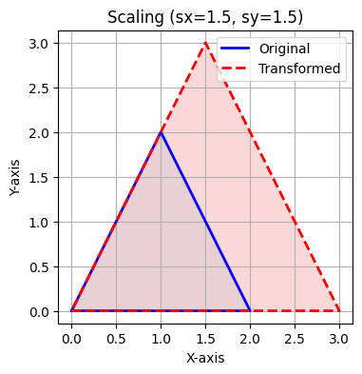
Rotated Triangle coordinates:
[[ 0.0000000e+00 0.0000000e+00 1.0000000e+00]
[ 1.2246468e-16 -2.0000000e+00 1.0000000e+00]
[ 2.0000000e+00 -1.0000000e+00 1.0000000e+00]]
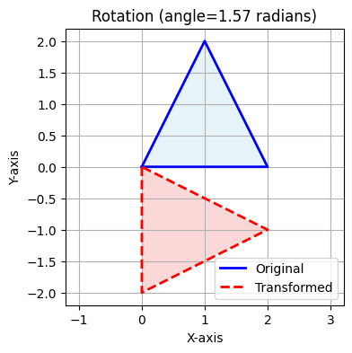

Reflected Triangle coordinates:
[[ 0 0 1]
[ 2 0 1]
[ 1 -2 1]]
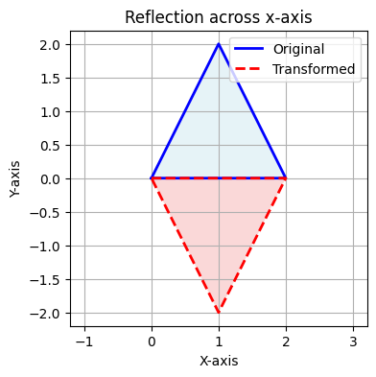
Sheared Triangle coordinates:
[[0. 0. 1. ]
[2. 1. 1. ]
[1. 2.5 1. ]]
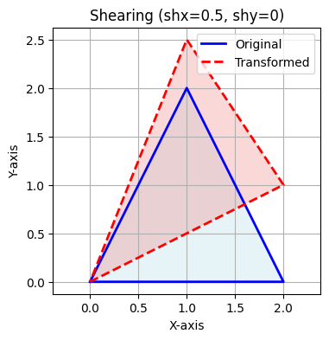
array([[0. , 0. , 1. ],
[2. , 1. , 1. ],
[1. , 2.5, 1. ]])

TASK – 2
